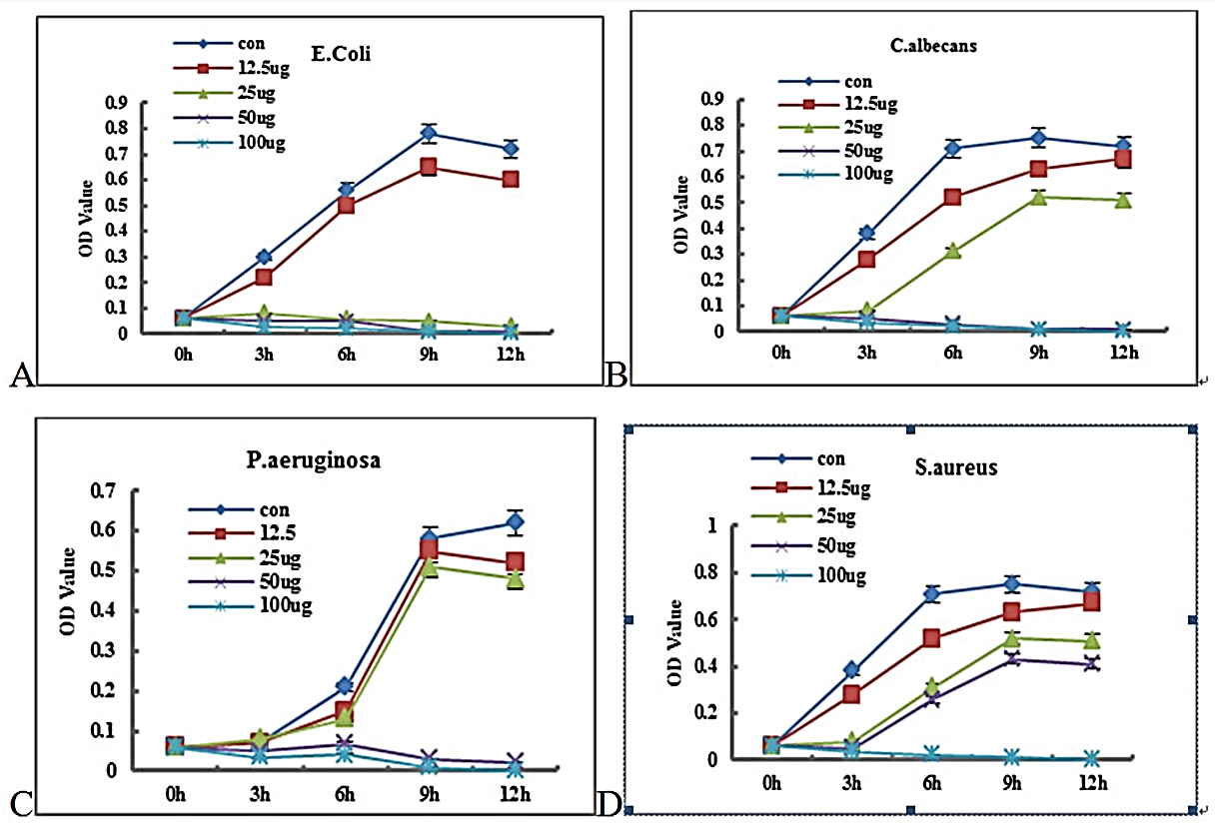
Investigating the effectiveness of the broad spectrum antimicrobial agent P-Ag-MSN
Figure 1A, 1B, 1C, and 1D. Growth curves of four micro-organisms in various concentrations of P-Ag-MSN (platelet derived growth factor incorporated into silver mesopore nanoparticles). The bacteria were Escherichia coli; Candida albicans; Pseudomonas aeruginosa; and Staphylococcus aureus.
The data above was obtained from a study investigating usefulness of P-Ag-MSN as a biomedical scaffolding material (see reference below). The specific idea behind the research was to investigate if P-Ag-MSN would be useful as a scaffold (support structure) to grow human tissue in a lab setting. One of the three factors looked at by the research was the antimicrobial activity of P-Ag-MSN. Antimicrobial activity is simply measuring how well something stops the growth of a range of microscopic organisms. The data above measures the effectiveness of P-Ag-MSN at stopping the growth of 3 bacteria (Escherichia coli; Pseudomonas aeruginosa; and Staphylococcus aureus), and one common fungus (Candida albicans). The concentrations mentioned above are in micrograms (µg) of the growth factor per millilitre of the silver mesopore nanoparticles.
What trends can be identified in each graph? Data to support this?
What conclusion can be drawn from each graph? Trend (or data) to support this?
What conclusion can be drawn from all four graphs? Trend (or data) to support this?

Reference
Ma C, Wei Q, Cao B, Cheng X, Tian J, Pu H, et al. (2017) A multifunctional bioactive material that stimulates osteogenesis and promotes the vascularization bone marrow stem cells and their resistance to bacterial infection. PLoS ONE 12(3): e0172499. doi:10.1371/journal.pone.0172499

